Generalized ERGO Annotation (GEA) Tutorial
Samson Tu and Mor Peleg
August 3, 2011

- Generalized ERGO annotation is done on Clinical Statements. There are 2 kinds of clinical statement annotation:
  - Simple Statement Annotation
Has two attributes:
(1) an anchor noun phrase (augmented NP), which describes a kind of event (observation or intervention that has happened to the patient) or feature of the patient. other noun phrases can be used to categorize or constrain aspects of the event or feature of the patient described by the anchor noun phrase;
(2) zero or more constraint expressions
  - Complex statement Annotation
Includes two sub-classes: AndOr_Annotation and Not_Annotation. These logical connectors are used to combine simpler statement annotations (simple and complex). See example 21 at the end of the document.

- Noun phrases
We model 3 types of noun phrases:
- Noun phrase, which has two subclasses:
Primitive noun phrase - specified by some terminology code (e.g., surgery)
Logical combination noun phrase
And two Expression subclasses:
- Context-dependent noun phrase - a noun phrase modified by a context modifier that defines the context of the NP, which changes the meaning of the concept (e.g., family history of asthma, consent for operation) – see example in the figure below
Example of context-dependent NP:
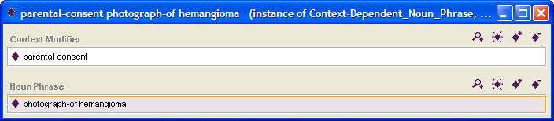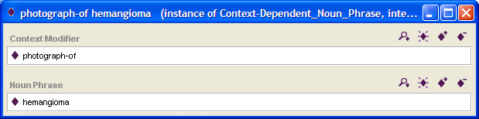
- Constrained noun phrase – an augmented noun phrase (NP or context-dependent NP) that is constrained by a constraint expression, as shown in Section 4 below.
- Time point extractors
The events or attributes that are described by a NP are associated with a value and time attributes. The following time point extractors can be used to extract time points associated with an event or attribute:
time – returns the time of a time-point event (e.g., time of surgery)
start – returns the start time of an interval for an event that spans a duration (e.g., start time of a medication prescription)
end – returns the start time of an interval for an event that spans a duration

- Constraint Expression
A constraint expression places a restriction on the value of the NP or on the time of the NP, or by placing a semantic relation that constrains the NP to a sub-set of the term without changing its meaning (e.g., severe asthma is-a asthma and if patient has severe asthma then patient has asthma is also true. However, patient consents to operation doesn't mean that the patient had the operation, and likewise, patient with family history of asthma doesn't mean that the patient has asthma). Constraints can be combined to create complex constraints on NPs. Thus, the different types of constraint expressions are:
4.1 Primitive constraint expression

4.1.1 Value constraint expression

Following is an example of a simple statement annotation of LVEF < 40%.
Here, the (primitive) NP is LVEF and the value constraint is < 40 % (example 29)

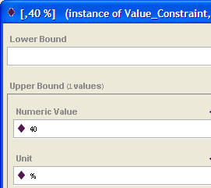
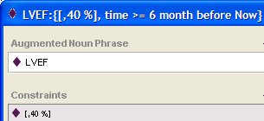

4.1.2 Temporal constraint expression

There are four types of temporal constraints: duration constraint, time point constraint, interval constraint, and frequency constraint,

4.1.2.1 Duration constraint expression

Following is an example of a simple statement annotation of Episodes of heartburn for 2 days or more (example 27) with a duration constraint (shown on the right).

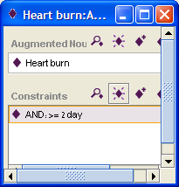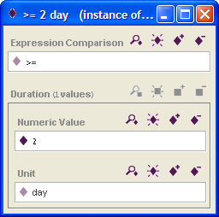

4.1.2.2 Time point constraint expression

A time point can be a time point literal (e.g., 10:00 on July 1, 2011), a time point reference (which is created using a time point extractor, e.g., start of Surgery), or a time point offset. An example of a time point offset is shown below.

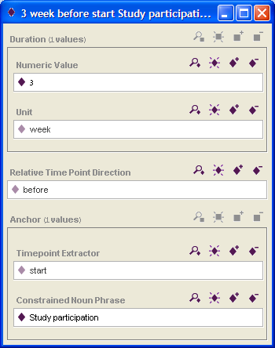

Following is an example of a simple statement annotation of prostate biopsy 3 weeks before study participation (example 18). Here we are assuming that the biopsy is a time-stamp occurrence and not interval-based. Therefore we apply to biopsy the time point extractor "time".

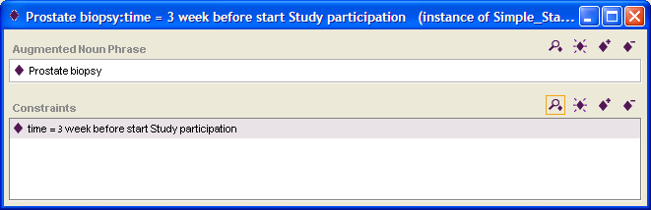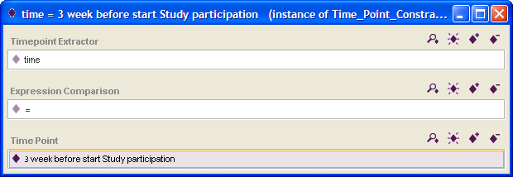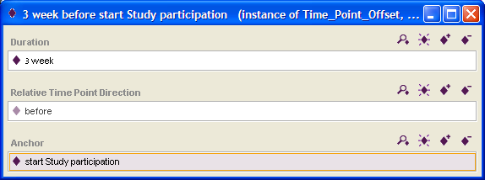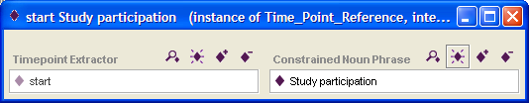

4.1.2.3 Interval constraint expression

Following is an example of a simple statement annotation of Episodes of heartburn during the last 7 days prior to baseline (example 27) with a time interval comparison constraint (shown on the top- right).

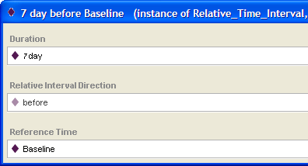
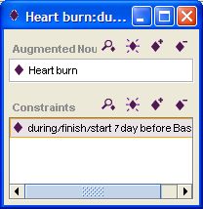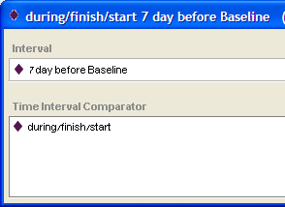

The (time) interval can be an expression. It is usually a relative time interval or. An example of a relative time interval is shown above (7 days before the reference time "baseline").

The time interval can also be (a non-relative) time interval. It is specified by a start time and a stop time, which are of types time point, or constraint, or expression.

4.1.2.4 Frequency constraint expression

Following is an example of a simple statement annotation of the following criterion:
"Weekly to biweekly assessments during the first 3-6 months of life." (example 43)
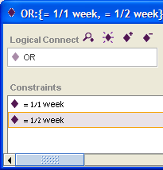
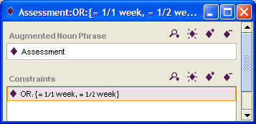

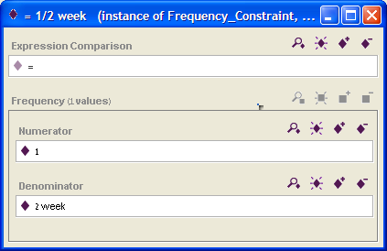

4.1.3 Relational constraint expression

A relational constraint constrains the NP to a sub-set of the term without changing its meaning (e.g., severe asthma is-a asthma and if patient has severe asthma then patient has asthma is also true.

Following is an example of a simple statement annotation of the following criterion:
"Asthma evidenced-by breathing problem".

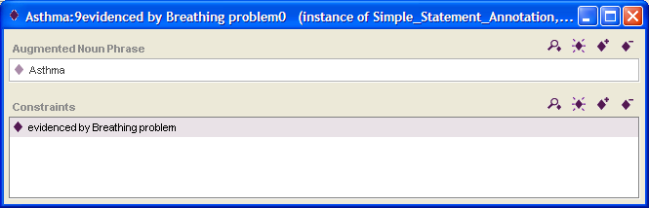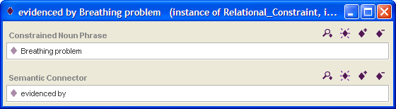

4.2 Compound constraint

Constraints combined by logical connectors: AND/OR, NOT.

Example 43: Parents agree to provide weekly to biweekly photographs of the patient's hemangioma(s) during the first 3-6 months of life.

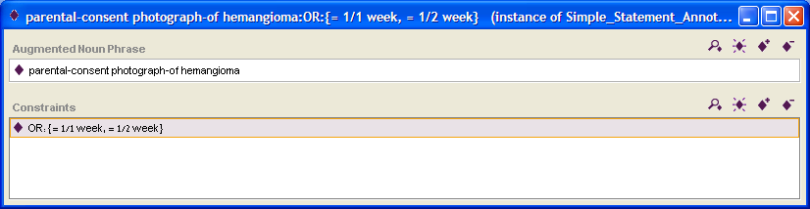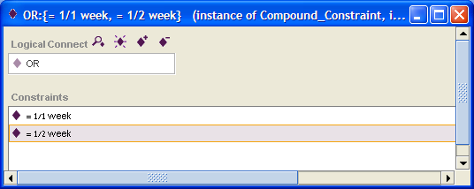

********************************

Example 21: Complex Statement Annotation with NOT

Example 21: Patients must not have used investigational agents during the past 6 months

